**Name : Ahmad Yasin**

**Roll No : 233605**

**Assignment #01 : Visual Programming**

* **Write a program to enter and sum the values on  a diagonal of 3*3*3 matrix.**

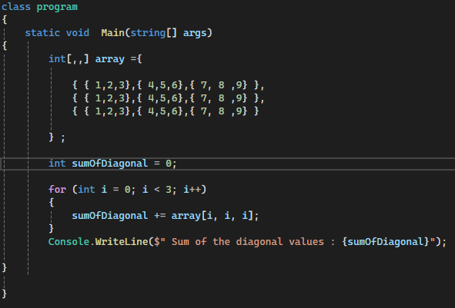

**Output :**

